# Import Index Component Price Information (Updated)

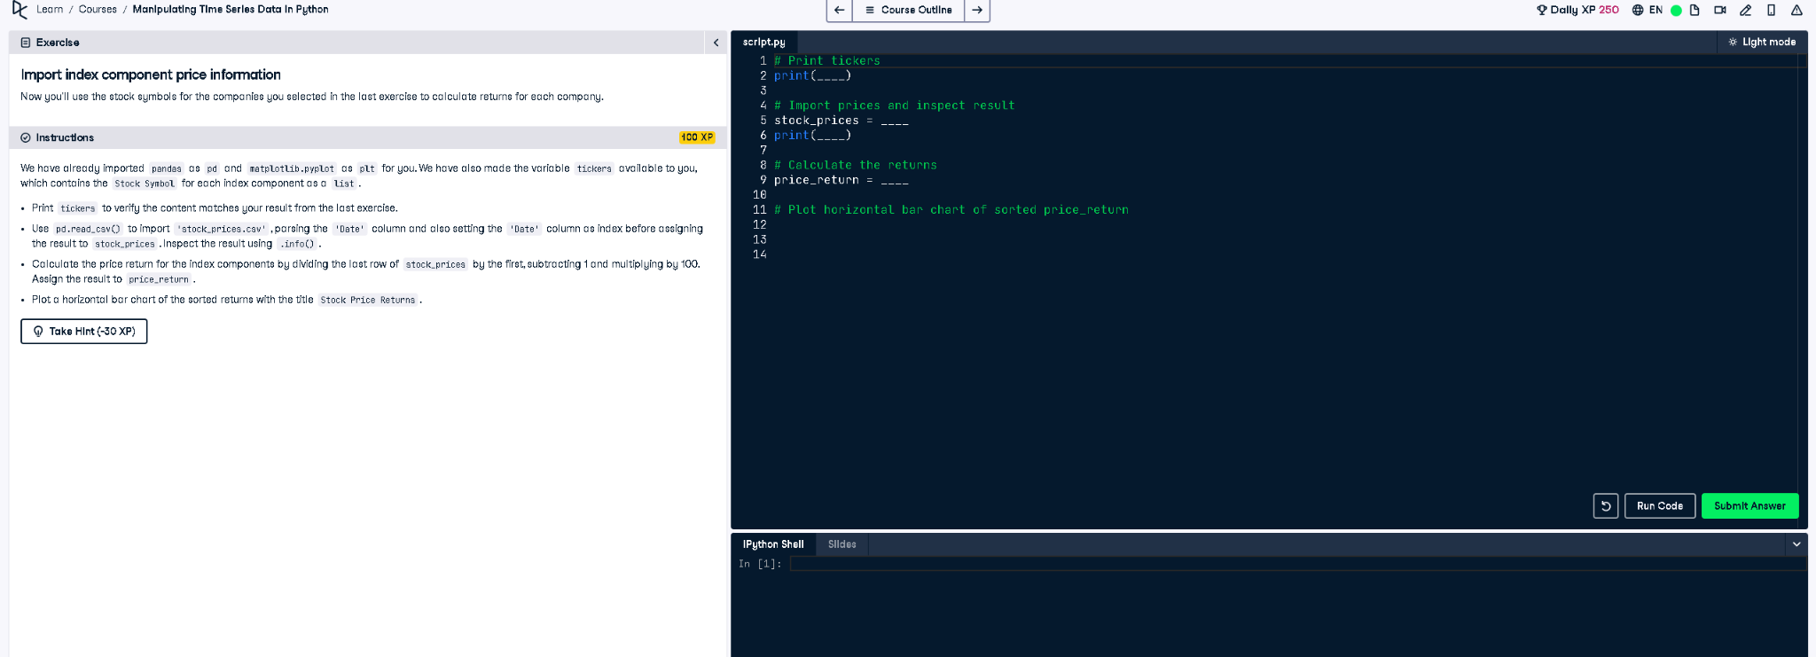

## ✅ Updated Full Correct Code:

# Print tickers  
print(tickers)  
  
# Import prices and inspect result  
stock_prices = pd.read_csv("stock_prices.csv", index_col="Date", parse_dates=True)  
print(stock_prices.info())  
  
# Calculate the returns  
price_return = (stock_prices.iloc[-1] / stock_prices.iloc[0] - 1) * 100  
  
# Plot horizontal bar chart of sorted price_return  
price_return.sort_values().plot(kind='barh', title="Stock Price Returns")  
plt.show()

## 📘 Explanation (Simple Terms):

This code imports stock prices for selected companies, calculates percentage returns from the first to last date, and displays a horizontal bar chart. The plt.show() function is used to ensure the chart appears, especially important when running the code outside notebooks or interactive environments.